Exercise 15
- List all employee ids and birth dates who were born before 1965.
SELECT id, date_of_birth FROM employee_data WHERE YEAR(date_of_birth) < 1965
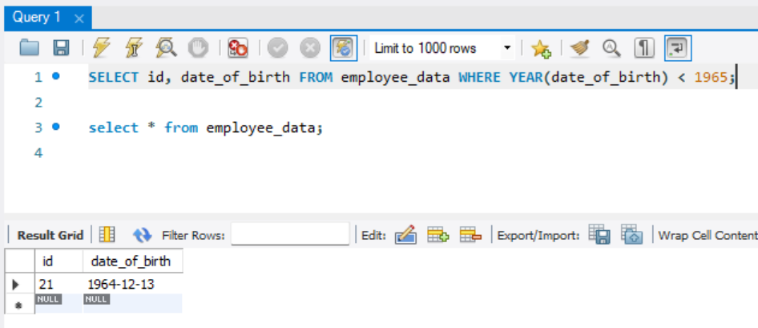
- Display Ids and birth dates of employees born in and between 1970 and 1972(this is tricky.. you need to give it a little thought)
SELECT id, date_of_birth FROM employee_data WHERE YEAR(date_of_birth) IN (1970, 1972) OR YEAR(date_of_birth) BETWEEN 1970 AND 1972;
